Weebly (OLQOP Website) How To

The good news is that Weebly makes website maintenance easy. If you can create and edit a Microsoft Word document then you can maintain the website. The primary concept is drag and drop. To logon go to: http://www.weebly.com/

Once you have logged on, you will see this screen:
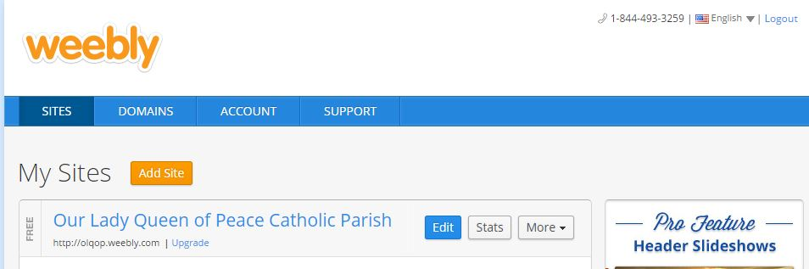
Weebly has a great support page that will answer all your questions on maintaining and updating the website. Click on the Support button above and you will see links to tutorials on every part and element of Weebly sites. This screen shot below shows just a few of the tutorials. So if you have a question on how to do something, start here.
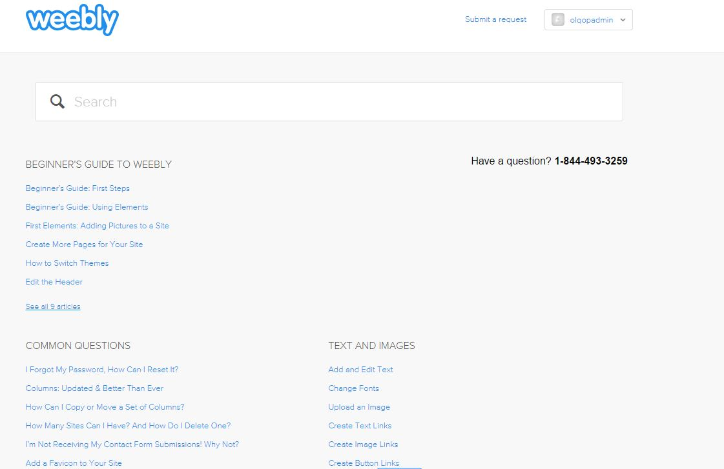
The Stats button gives information about the number of page views and the number of unique individuals who have visited the site. By hoovering over a dot you see the number for the given day. No other details are available.
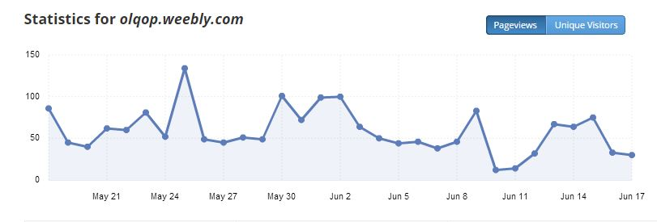

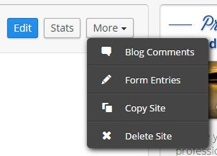
The More button lets you do such things as delete the site, copy it to a separate site, look at blog comments (we don't have a blog page), and look at form entries. If you wish to see how a new design might look, copy the site and practice on it first. It's easy to implement a new design but it does require a bit of time and effort.

The OLQOP website has a contact form and clicking on the form entries button allows you to see all contact form submissions. (It is not reproduced here due to privacy concerns.)

Because Weebly does provide a great support system, there are no details on how to update the site in this document. Instead this document will simply show you how to get started and will outline the weekly and monthly maintenance duties.

To begin, click on the blue Edit button. The next thing you see is:

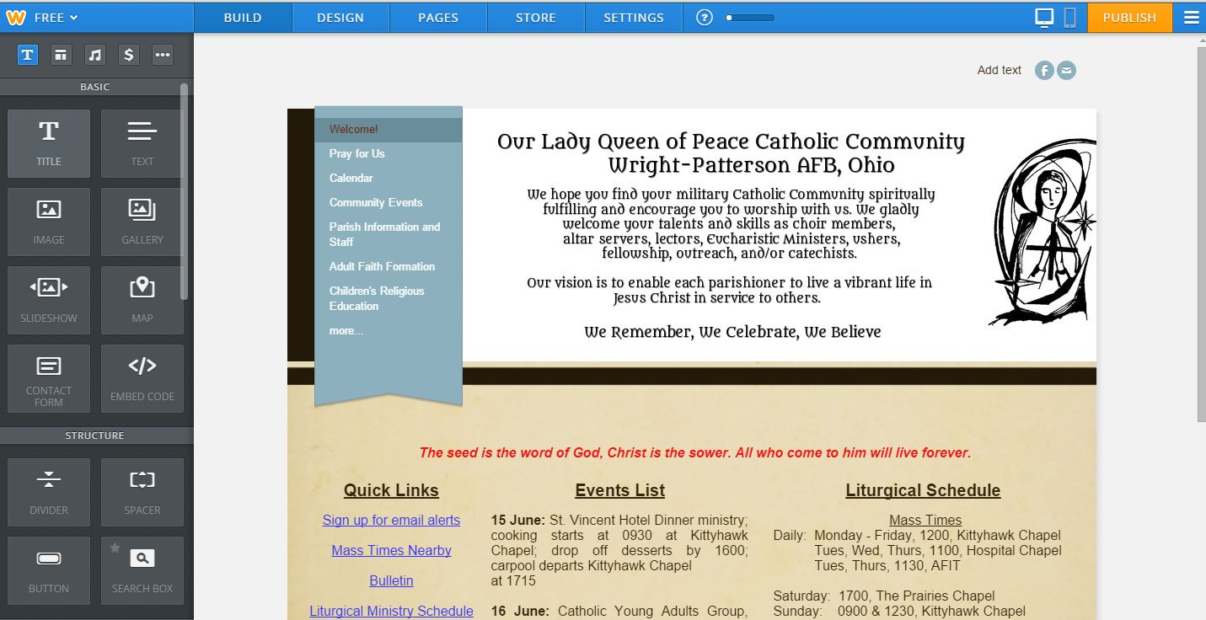
From now on this tutorial will refer to this picture. Please become familiar with the various parts:
1. The top bar – buttons for Build, Design, Pages, Store, Settings, Publish, drop down.
a. Publish: Click on this button after you have made changes. (Changes will not show up on the website until you do.)
b. Drop Down: Click on the Drop Down and then Exit Editor when you are done with all changes.
c. Build. When you arrive on this page initially you are automatically on the Build button.
d. Design. If you wish to change the layout, fonts, you select Design.
e. Pages. If you wish to add a page, delete a page, or hide a page, click on the Pages button (more later).
2. The elements bar on the left. This is the menu you drag from. (Notice the slider bar to find other elements.)

The important points here are publishing and exiting (1a and 1b). When you exit, you also must logout.

For all other questions about actions and information see the Weebly Support page.
Weekly Updates
The primary actions on a weekly basis are:
1. Update the home or welcome page with upcoming events.
2. Update the Weekly Bulletin page with the new bulletin.
3. Update the Pray for Us page.

The Parish Coordinator or Administrative Assistant will send the bulletin and the prayer list on Thursday or Friday of the week.

Use the information in the bulletin to update the Events List on the Welcome page and check the names in the prayer list against the Pray for Us page.

Open the bulletin in Microsoft Word and save it as a PDF. Navigate to the Weekly Bulletin page. Delete the old bulletin under the Archive header. Drag the Microsoft Word version of the previous week's bulletin down under the Archive header. Upload the new Microsoft Word and PDF versions of the bulletin above the Archive header.

To the right of these files you will see .jpg versions of the left and right side of the bulletin. These take a little effort to create and require you to have a way of making the .jpg. Once you have created them, simply click on the old image, select replace image, and upload the new version. Make sure the blue button in the top right corner is "ON:"
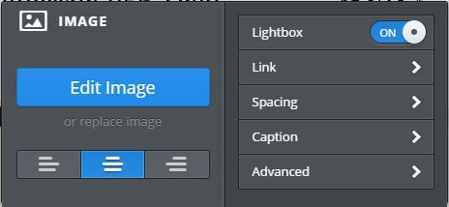

FYI, I use Adobe Photoshop Elements to create the left and right side bulletin .jpg images. There are probably other ways to do it.
a. One way is to scan each side separately and save them as .jpg. For those who don't have software, the scan process is probably the easiest.
b. The other way is to use the Snipping tool that comes with the Microsoft operating system. Use the tool to capture each side after you have made the changes to the left side noted below.

FYI, before you create a new version of the left side, be sure to first edit the collection box and the Mass Schedule line. Here is an updated version as an example:
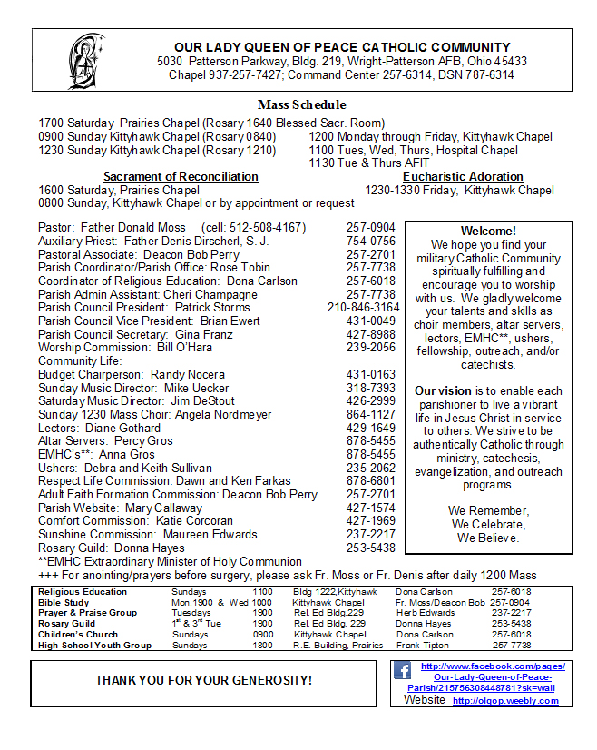
If any names or phone numbers change here, you may need to update the following pages:
- Parish Information and Staff
- Adult Faith Formation and subordinate pages
- Children's Religious Education and subordinate pages
- Parish Council
- Liturgical Ministers

MONTHLY UPDATES/CHECKS
There are three tasks for the monthly maintenance. They are bit time consuming but necessary for the integrity of the site.
1. Click on every link and make sure the link is "not dead." For pages within OLQOP it is unlikely (but possible) to find a dead link. You will find such a thing if you have deleted the page but not gone back to find any links to it. It is more likely to find dead links to external websites. When you do, simply delete the link and the text of the link OR find the correct new URL (web address) and update the OLQOP web link. All links on the website are in blue and are underlined.
2. Make sure the site map has a listing (and link) for each and every page on the OLQOP website.
3. Log into the OLQOP gmail account and check the Google calendar to make sure it is correct with regard to events and the liturgical schedule.
4. Check the left side of the current bulletin against the various places names and phone numbers occur (see above) to ensure consistency.
5. Review the policy page to make sure no new policies have superseded that found on the OLQOP website. If there are new policies, update the page.
6. Periodically, clean out images from past events.
7. Occasionally, change the Scripture on the Welcome page. Pick a psalm refrain or antiphon:
